**PROJECT TITLE**: COMPREHENSIVE DIGITAL MARKETING

FOR NOISE

**STUDENT NAME:**DHAVALESWARAPU CHARITHA

**PROJECT SUPERVISOR:** DR.VAROODHINI

**DEPARTMENT**:BACHELOR OF BUSINESS ADMINISTRATION **COLLEGE**:SATYA INSTITUTE OF TECHNOLOGY AND MANAGEMENT

**TEAM ID :**LTVIP2025TMID24590

**COMPREHENSIVE DIGITAL MARKETING FOR NOISE**

**

**Introduction**

Noise is a prominent Indian consumer electronics brand that has made significant strides in the wearable and hearable technology market. Noise is an India-based company that was established in 2014. It has gained recognition for its wide range of products, including smartwatches, wireless earbuds, and other tech accessories The brand primarily targets young, tech-savvy Indian consumers.

Noise has achieved considerable success in the Indian market, becoming a leading brand in its product categories.In essence, Noise has effectively positioned itself as a dynamic and consumer-focused brand, catering to the evolving needs of the Indian digital landscape.

In essence, Noise has effectively positioned itself as a dynamic and consumer-focused brand, catering to the evolving needs of the Indian digital landscape.

## PART 1.BRAND STUDY,COMPETITOR ANALYSIS &BUYER’S/AUDIENCE PERSONA

##### BRAND IDENTITY RESEARCH

MISSION

Noise’s mission centers on “democratizing connected lifestyle for Indians.” This means making accessible, feature-rich technology available to a broad audience.Noise’s mission centers on “democratizing connected lifestyle for Indians.” This means making accessible, feature-rich technology available to a broad audience.They strive to provide innovative and high-quality mobile accessories, and smart wearables to enhance the digital experience of their customers.

UNIQUE SELLING POINT

Noise offers competitive pricing, making smartwatches, earbuds, and other tech accessible to a wide range of consumers. They emphasize stylish designs that resonate with young, fashion-conscious consumers.

NOISE MESSAGING:

Noise’s messaging emphasizes a youthful, energetic, and tech-savvy lifestyle.They promote their products as essential accessories for fitness, music, and everyday connectivity.They use social media and influencer marketing to connect with their target audience on a personal level.

TAGLINE:

NOISE use the tagline “India’s No.1 smart wearable brand ”They highlight their "Make in India" initiative. Noise’s taglines and marketing materials often highlight the idea of “staying connected,” “being active,” and “expressing your style.”

Noise has successfully carved out a niche in the Indian market by offering affordable, stylish, and feature-rich tech products. Their mission and messaging are clearly aligned with the needs and preferences of their target audience, and their strong digital presence has enabled them to achieve significant growth.

## Competitor analysis

Competitor 1:boAt

* A major competitor in the Indian audio and wearable market Known for its aggressive pricing, strong marketing, and wide range of products.
* boAt has a very strong brand presence within the Indian market.
* Very strong online sales presence.

Competitor 2:xiaomi

* A global electronics giant with a significant presence in India.
* Offers a diverse portfolio of products, including smartwatches, earbuds, and smartphones.
* Xiaomi leverages its established brand reputation and competitive pricing.

Competitor 3: Samsung

* A global leader in consumer electronics.
* Provides high-end smartwatches and earbuds with advanced features.
* 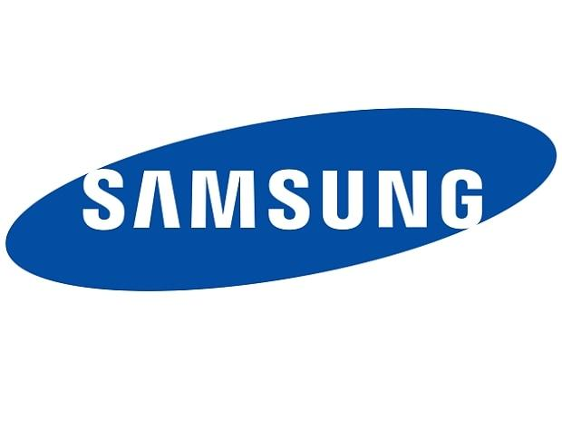Samsung focuses on innovation and premium quality.

## Buyer’s /Audience’s persona

**DEMOGRAPHICS**

* Name : Rahul
* Age:18-25
* Occupation:marketing manager
* Location:urban
* Education: Bachelor’s degree in Marketing

**PSYCHOGRAPHICS**

* Values:style,affordability, convenience, technology, fitness
* Interests:music,gaming, social media
* Lifestyle:Active, social,digitally connected
* Tech adoption:Early adopters of new technology

**GOALS**

* To own stylish and functional tech gadgets
* To stay connected and entertained on the go
* To track fitness and health metrics

**CHALLENGES**

* Finding affordable yet high quality tech products
* Keeping up with the latest tech trends
* Balancing style and functionality

**BUYING BEHAVIOR**

* Researches products online before purchasing
* Influenced by social media platforms
* Seeks value for money

By understanding this buyer personab,Noise can tailor it’s marketing and product development strategies to effectively reach it’s target audience.

PART 2.SEO &KEYWORD RESEARCH

SEO AUDIT

SEO is the practice of optimizing websites to rank higher in search engine results, driving organic traffic.

A comprehensive SEO audit for a noise company should prioritize technical health, on-page optimization, and off-page authority. Key areas include site speed, mobile-friendliness, schema markup for noise-related products, and targeted keyword analysis (e.g., “noise reduction,” “soundproofing”). Content should focus on educational resources and product demos. Backlink analysis should identify quality sources relevant to acoustics and construction. Local SEO is crucial if the company serves specific regions, ensuring accurate NAP citations and Google My Business

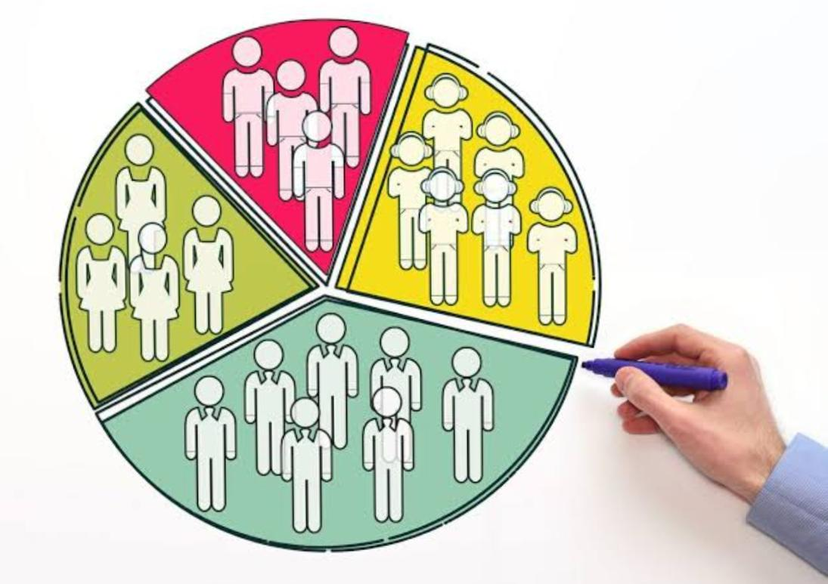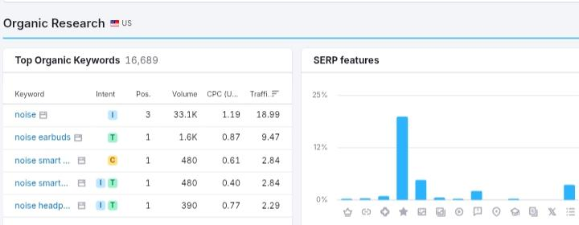

## KEYWORD RESEARCH

## Keyword research for Noise targets India’s tech-savvy, price-conscious market. Prioritize “affordable smartwatches,” “wireless earbuds India,” and product-specific terms like “Noise ColorFit Pro 3 review.” Capture user intent with “best smartwatch under 1000₹” and “earbuds for music.” Localized keywords like “ Mumbai Noise store” are crucial. Analyse competitor keywords to identify opportunities.

## 

## ON PAGE OPTIMIZATION

## Noise’s on-page SEO should prioritize user experience and keyword integration. Optimize product pages with detailed descriptions, high-quality images, and customer reviews. Use relevant keywords in titles, meta descriptions, and headings, ensuring natural placement. Create engaging blog content addressing fitness, audio, and tech trends. Implement a clear site structure with optimized URLs and internal linking. Ensure mobile responsiveness and fast loading speeds, crucial for India’s mobile-first audience. Optimize images with alt text and compress files. Utilize schema markup for structured data. Focus on clear navigation and product comparisons. Encourage user-generated content, especially product reviews.

## CONTENT IDEAS AND MARKETING STRATEGIES

## Noise should leverage a mix of product-focused and lifestyle content. Product reviews, “how-to” videos, and user-generated content build trust. Fitness and music-themed content resonates with their active audience. Influencer partnerships and targeted social media ads drive engagement. E-commerce optimization and email marketing boost sales. “Make in India” campaigns and customer review strategies build brand loyalty. Interactive content like polls and AR filters increases engagement. Retargeting ads capture interested buyers. Experiential marketing at events creates brand awareness, and podcasts establish expertise.

## 3.CONTENT IDEA GENERATION & STRATEGY

MARKETING STRATEGIES

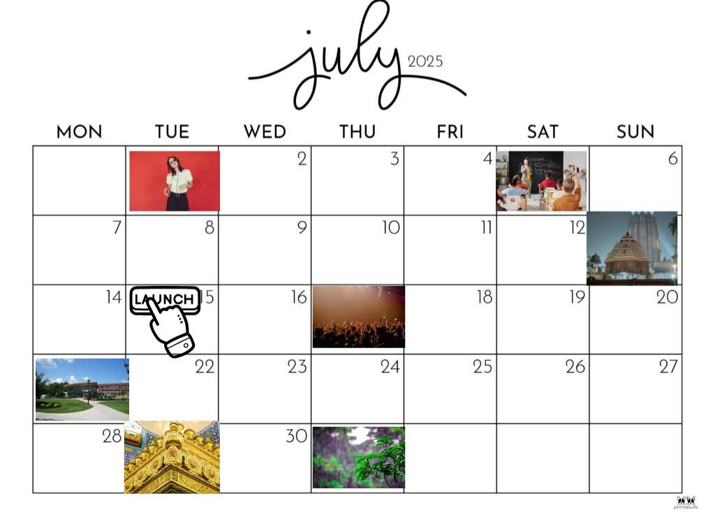Noise should prioritize digital-first strategies: influencer marketing with fitness and music personalities, targeted social media campaigns on Instagram and YouTube, and optimized e-commerce listings. Content should focus on lifestyle integration, showcasing product use in fitness, travel, and daily life. Leverage “Make in India” messaging and regional language content. Gamification and interactive AR filters boost engagement. Personalize campaigns based on user data. Run exclusive online deals and build a strong online community. Prioritize video content, especially short-form, for maximum .

July 1: Potential focus on monsoon-related audio content or products

July 5: Guru Purnima: Create content that celebrates the importance of mentors and teachers, perhaps with audio meditations or inspirational talks.

July 13: Jagannath Rath Yatra : If applicable, create region-specific content or promotions related to the festival's soundscapes.

July 15: Product Launch: Announce a new audio product or feature with a focus on Indian musical preferences or needs

July 17: Hariyali Teej: Create content related to festive music and celebration.

July 21: Back-to-School/College Campaigns: Target students with promotions on headphones and audio accessories, emphasizing focus and concentration.

July 29: Muharram : Be mindful and respectful in your marketing messaging.

July 31: Focus on Monsoon Sales: Offer deals on waterproof or noise-canceling products as monsoon season continues.

Noise’s content should blend product demos, lifestyle integration, and user engagement. Create “how-to” videos, fitness challenges, and music playlists. User-generated content, AR filters, and live Q&As build community. Highlight “Make in India” stories and regional language content. Optimize for short-form video and e-commerce platforms.

PART4:CONTENT CREATION AND CURATION

POST CREATION

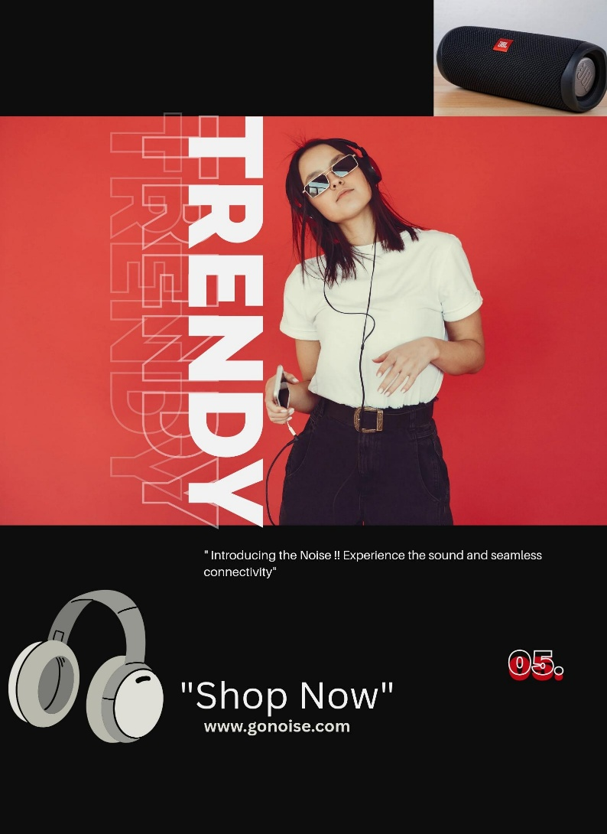For Noise, impactful social media posts blend product showcases with lifestyle integration. Instagram visuals should highlight stylish wearables and active lifestyles, using high-quality images and engaging reels. YouTube content should include detailed product reviews, “how-to” tutorials, and feature demonstrations.

Format 1: Advertising through Podcasts

Idea: Noise Company collaborates with popular Indian podcasters (tech, lifestyle, music) for sponsored segments.

Date: July 28, 2023 (or a date you choose)

Aim: To reach a wider audience, especially tech-savvy and music-loving demographics.

Format 2: Creating Ads and Posting on Social Media

Idea: Noise Company launches a social media campaign featuring user-generated content (UGC) and influencer collaborations.

Date: July 28, 2023 (or a date you choose)

Aim: To increase brand awareness and engagement through visually appealing ads and relatable content.

Format 3: Creating Videos

Idea: Noise Company produces short, engaging videos showcasing product features, Indian music playlists, and noise cancellation demos in real-world Indian scenarios (e.g., crowded commutes, busy markets).

Date: July 28, 2023 (or a date you choose)

Aim: To demonstrate product benefits and connect with the Indian audience through relatable visuals and storytelling.

DESIGN/VIDEO EDITING

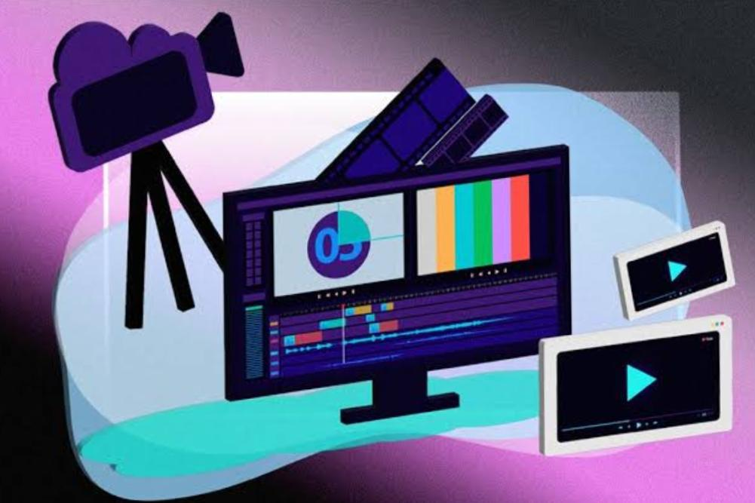

Noise’s video editing should be energetic and stylish, reflecting their youthful brand. Employ quick cuts, dynamic transitions, and upbeat music. Highlight product features with close-ups and on-screen graphics, while showcasing lifestyle integration through real-world scenarios. Use modern typography and motion graphics for clarity. Optimize for social media with vertical videos and trending audio.

Focus on high-quality sound and color grading that aligns with Noise’s brand. Incorporate user-generated content and influencer collaborations for authenticity. Create diverse content, from product reviews to fitness videos, and optimize for each platform. Use engaging thumbnails and relevant keywords. Prioritize short form videos.

SOCIAL MEDIA AD CAMPAIGNS

Noise’s video editing must be fast-paced and visually dynamic, targeting a young, tech-savvy audience. Use quick cuts, vibrant graphics, and trending music. Product showcases should highlight key features with clear visuals and concise on-screen text. Lifestyle segments should feature real-world scenarios, emphasizing the products’ integration into daily life.

Optimize for social media with vertical formats and trending audio. Incorporate user-generated content and influencer collaborations for authenticity. Prioritize clear audio and color grading that aligns with Noise’s brand aesthetic. Create diverse content, including product reviews, tutorials, and fitness-themed videos.

Use engaging thumbnails and relevant keywords for SEO. Short-form videos are crucial for platforms like Instagram Reels and TikTok. Maintain consistency in style and branding across all video content.

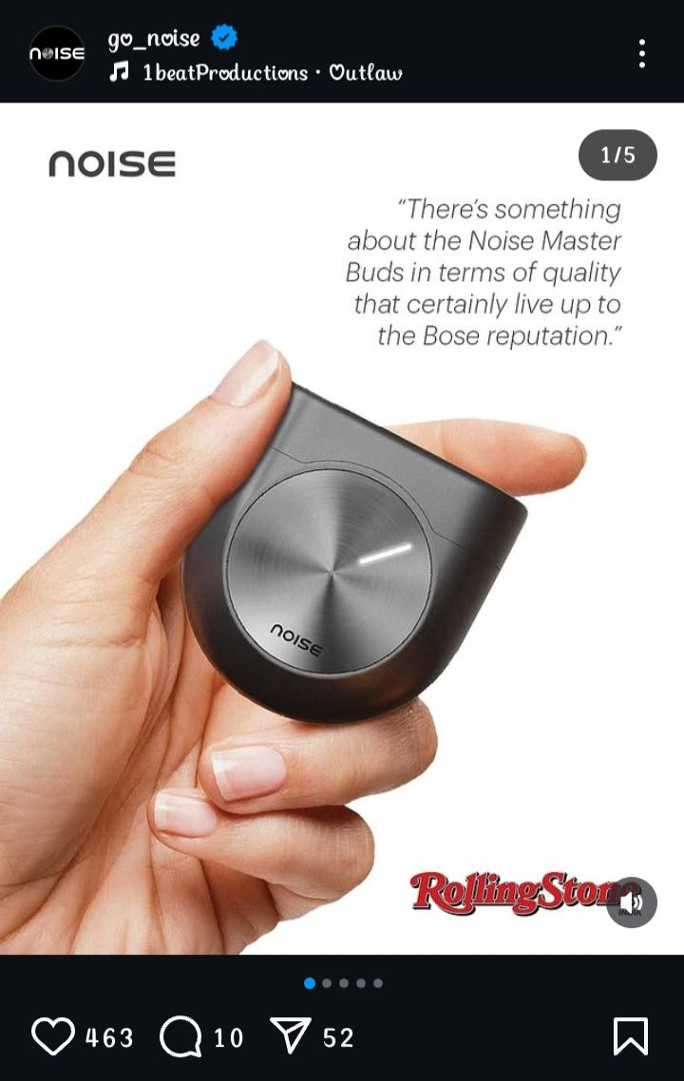*INSTAGRAM*

*LINKEDIN*

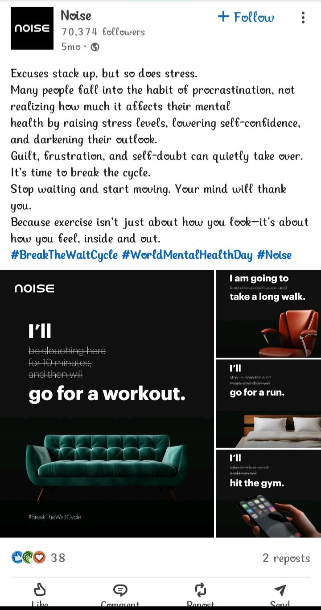EMAIL AD CAMPAIGNS

Noise’s email campaigns should be segmented and personalized, targeting specific customer interests and purchase history. Begin with a welcome series for new subscribers, highlighting popular products and exclusive deals. Use product-focused emails showcasing new releases, detailed features, and customer reviews.

For fitness enthusiasts, create workout-themed emails with smartwatch features and curated music playlists. Audiophiles should receive emails featuring earbuds with high-quality audio and noise cancellation capabilities. Target students with budget-friendly tech and discounts.

Implement abandoned cart reminders with personalized product recommendations and limited-time offers. Use interactive elements like quizzes and polls to increase engagement. Send post-purchase emails with care tips and accessory recommendations.

Promote seasonal sales and flash deals with urgent language and clear calls to action. Incorporate high-quality visuals and short, engaging copy. Track open rates, click-through rates, and conversions to optimize campaigns. Use A/B testing to refine subject lines and email content.

**CONCLUSION**

## In conclusion, Noise’s digital marketing success hinges on a multi-faceted, data-driven strategy that resonates with its young, tech-savvy Indian audience. By prioritizing mobile-first optimization, engaging video content, and targeted social media campaigns, Noise can amplify its brand presence. Leveraging influencer partnerships, user-generated content, and personalized email marketing will foster a strong community and drive conversions.

## 